

Redborne Upper School

RECRUITMENT PACK

TEACHING ASSISTANT - LEARNING SUPPORT

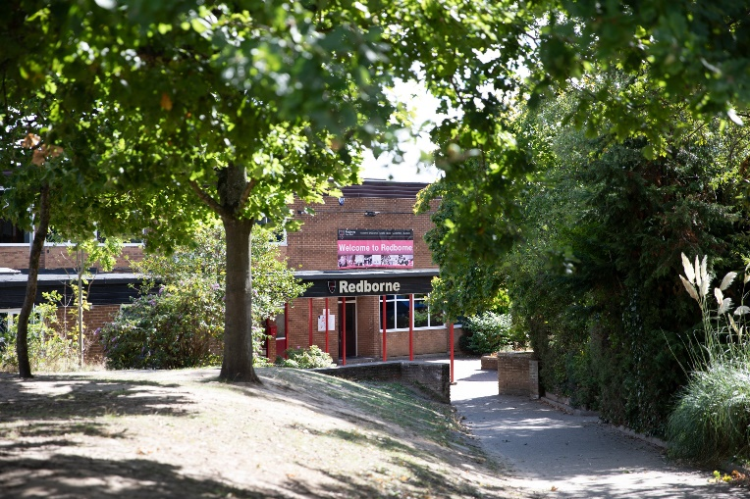
SEPTEMBER 2026

HEADTEACHER’S WELCOME


Thank you for your interest in Redborne Upper School and Community College.

Redborne is a vibrant and ambitious age 13-18 upper school, including a thriving sixth form of around 400 students, located in the heart of Ampthill, Bedfordshire. As a large academy with over 1,600 students on roll, we are proud to serve our community by providing high-quality education that combines strong academic achievement with outstanding personal development.

Our school is built on values of inclusion, respect and aspiration. We aim to foster a learning environment where all students feel supported to reach their full potential, both in and beyond the classroom. As a designated training school, we are deeply committed to the development of teaching and learning. This not only benefits our students, but also creates a culture of continuous professional growth for our staff.

Redborne is a unique place to work, not least because of our on-site working farm, which enriches the curriculum and offers students the chance to gain practical qualifications in agriculture. It reflects our wider belief that education should be broad, balanced, and rooted in real-life experiences.

In our most recent Ofsted inspection (July 2024), Redborne was judged to be a ‘Good’ school. We are proud of this outcome and remain focused on further developing the quality of our provision, especially in pursuit of excellence for every student.

If you share our commitment to high standards, professional development, and inclusive education, we would be delighted to receive your application.

Olly Button

Headteacher

OUR VISION

Our Vision

At Redborne, we are committed to becoming one of the best schools in the country. In order to help us achieve this goal, we will:
- Have outstanding behaviour based upon positive relationships.
- Ensure that all our students enjoy learning from teachers who love teaching.
- Ensure that everyone achieves their full potential.

Staff and students work together towards realising our vision, by linking everything we do to one of our three core values, ‘Aspiration’, ‘Responsibility’, and ‘Respect’. Every aspect of a student’s Redborne experience is aimed at promoting these:
Aspiration

For everyone to achieve.
For everyone to participate.
For everyone to be the best they can be.
For everyone's future.

Responsibility

For our behaviour / actions.
For our commitment to learning.
In our (wider) community.

Respect

For and between everyone.
For others' views / beliefs.
For the school building and environment.

OFSTED SAYS

"Pupils behave well around the school and during lessons. They are polite and courteous to adults. There are positive relationships between staff and pupils."

OUR CAMPUS
Redborne, a 13-18 Upper School since the early 1970s, is ideally placed to provide community education in the area. Redborne serves Ampthill, Flitwick, Maulden and other neighbouring villages.

The school is spread over 40 acres of attractive grounds, with a wide variety of trees, shrubs, flower beds and rock gardens. There are rugby, football, rounders and cricket pitches, netball and tennis courts, as well as an athletics track in the summer.

In addition, there is a floodlit all weather sports area with an adjoining pavilion, as well as a recently refurbished floodlit 3G football pitch. The school also has its own farm, used to deliver both livestock and horticulture courses - an invaluable learning resource for students.

We cannot describe all aspects of such a large and active school and we therefore offer an invitation to visit us and find out more. Please contact us for an appointment:

Telephone: (01525) 404462

Website: www.redborne.com

Email: admin@redborne.com

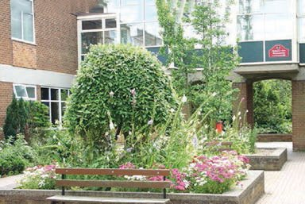

TEACHING ASSISTANT
- Start Date: September 2026 or ASAP
- Contract: Full-time (36 hours/week, term-time only + 5 training days) There is flexibility on the hours and we would consider school hours for the right candidate.
- Salary: Level 2 (Point 3–6)
- Actual Salary Range: £20,542.00 – £21,531.00 (dependent on experience)
- Part-time applications are welcomed

Are you looking for a role where you can make a real difference and develop your career in education?

We are seeking a flexible, committed and enthusiastic Teaching Assistant with strong Maths and English skills to join our thriving school community and learning support team.
Are you passionate about young people in their learning?
Do you thrive in a supportive and dynamic school environment? We are looking for a dedicated and enthusiastic Teaching Assistant to join our fantastic team!
At Redborne, we believe every child deserves the best start. As a Teaching Assistant in Learning Support, you will play a vital role in supporting our students' learning and development. You will work closely with our SENDCO and teachers to create an engaging and inclusive classroom experience.
About the Role

This is an exciting and varied role supporting students with their learning and development. Teaching Assistants play a vital supportive role, helping to ensure students receive tailored support to succeed academically and socially while enabling teachers to deliver effective lessons. You will create a productive learning environment by:

- Providing additional help to students who may struggle.
- Encouraging participation and engagement in lessons.
- Helping students stay focused and on task.
- Reporting on student progress and behaviour to the staff and parents / carers.
- Support pastoral care by helping students with personal or social issues.

Who We’re Looking For

We welcome applications from those who are:

- Experienced school staff ready for a new challenge.
- Anyone who aspires to progress to become a HLTA
- Someone with strong Maths and English skills.
- Patient, kind and nurturing.
- Proactive and adaptable.
- Committed to fostering a positive learning atmosphere.
- Qualified teachers seeking a return to education after a career break.

What We Offer

- A supportive and inspiring team environment
- Outstanding professional development opportunities – HLTA courses will be funded for the right candidate.
- A clear pathway for career progression into teacher training
- The opportunity to be part of a school community that values every member of staff

Working Hours

Monday – Thursday: 8.30am – 4.15pm
Friday: 8.30am – 4.00pm
Part-time hours can be discussed at the interview.

If you are passionate about education, eager to develop your skills, and ready to make a real impact — we would love to hear from you!

Visits to the school are welcome by appointment.

Apply now and take the next step in your education career journey!

Closing Date: Sunday 7th June 2026
We reserve the right to close the application process early.
Interview Date: TBA

JOB DESCRIPTION

Job title: Teaching Assistant
Hours: 36 hours Term Time Only plus 5 training days
Monday – Thursday 8.30am – 4.15pm and Friday 8.30am – 4.00pm (30 minutes for lunch)
Responsible to: Headteacher
Line manager: SENDCO
Job purpose: To provide learning support to students with a variety of learning difficulties under the direction of the SENDCo and in collaboration with subject teachers.
MAIN DUTIES AND RESPONSIBILITIES
- To offer support to all students in class, in collaboration with subject teachers.
- To provide increased support to individual students with some oversight/support of their medical needs.
- To help students keep up with coursework demands.
- To assist with the practical organisation of students’ learning.
- To provide feedback to subject teachers and Head of SENDCO on student progress.
- To contribute to the formulating of IEPs and Education Health and Care Plan Review Reports.
- To provide and encourage a positive framework for students’ learning.
- To advise teaching staff on effective techniques and strategies to meet a student’s specific needs.
- To keep abreast of developments within SEND and to show a commitment to on-going professional development.
- Where appropriate, to withdraw a small group of students to work on a specific task under teacher direction/supervision.
- To support students with SEND in before and after school interventions (study club), where appropriate.
- To supervise the SEND break / lunchtime club – this includes doing activities with the students.

OTHER DUTIES AND RESPONSIBILITIES:
1. To comply with Redborne’s commitment to safeguarding and promoting the welfare of children and young people.
2. To maintain confidentiality at all times in respect of school-related matters and to prevent disclosure of confidential and sensitive information.
3. The post holder must at all times carry out his/her job responsibilities with due regard to Equal Opportunities'.
4. To undertake any other duties of a similar level and responsibility as may be required.
PERSON SPECIFICATION

ESSENTIAL | DESIRABLE
Education & Qualifications
Education to GCSE standard with a minimum of 5 passes at GCSE (9 - 4 including English and Maths or equivalent qualifications). | Relevant advanced (Level 3) vocational qualifications (NVQ, BTec, ‘A’ Levels)  Higher Education qualification  Confidence and ability to support in Mathematics classes
Experience
Experience in a school environment
Experience of working with young people
Experience of administration
Experience of leading a group of young people (e.g. as a sports coach or in a youth group)
ICT Skills
Ability to use computers, competent in using Microsoft and Google Docs
Personal Qualities
Well organised and capable of showing attention to detail
A flexible approach
Good interpersonal skills
Able to work under pressure
Able to work as part of a team
A commitment to quality and continuous improvement
Communication Skills
Able to communicate effectively verbally and in writing | Competence in communicating using ICT (e.g. Microsoft Office or Google documents)
Development & Training
Willingness to undertake further work-related training | Holds a First Aid certificate  Evidence of existing professional development
All offers of employment are “conditional” until Disclosure and Barring and qualification checks have been successfully completed and satisfactory references have been received. Redborne is committed to safeguarding and promoting the welfare of children and young people and expects all staff and volunteers to share this commitment.

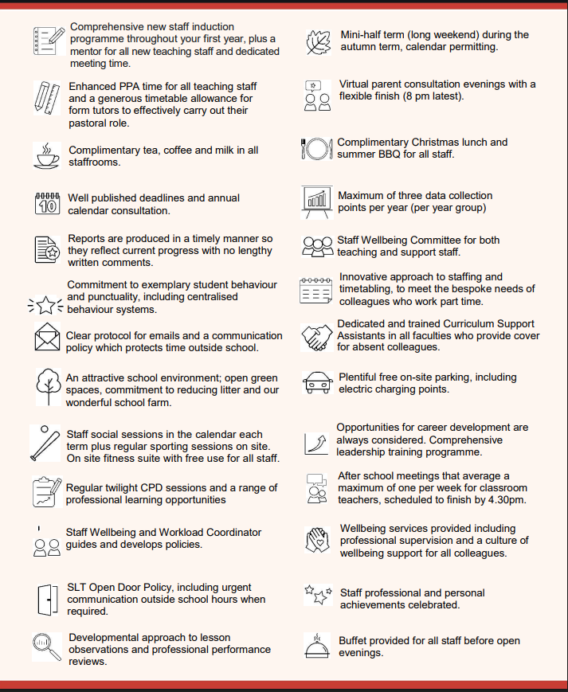
STAFF WELLBEING CHARTER

